Link to download: [MySQL](https://www.mysql.com/)

Scroll down to

Click on MYSQL Community

Download first one

Do no sign up, click on no thanks just start my download.

After installation click ‘full’

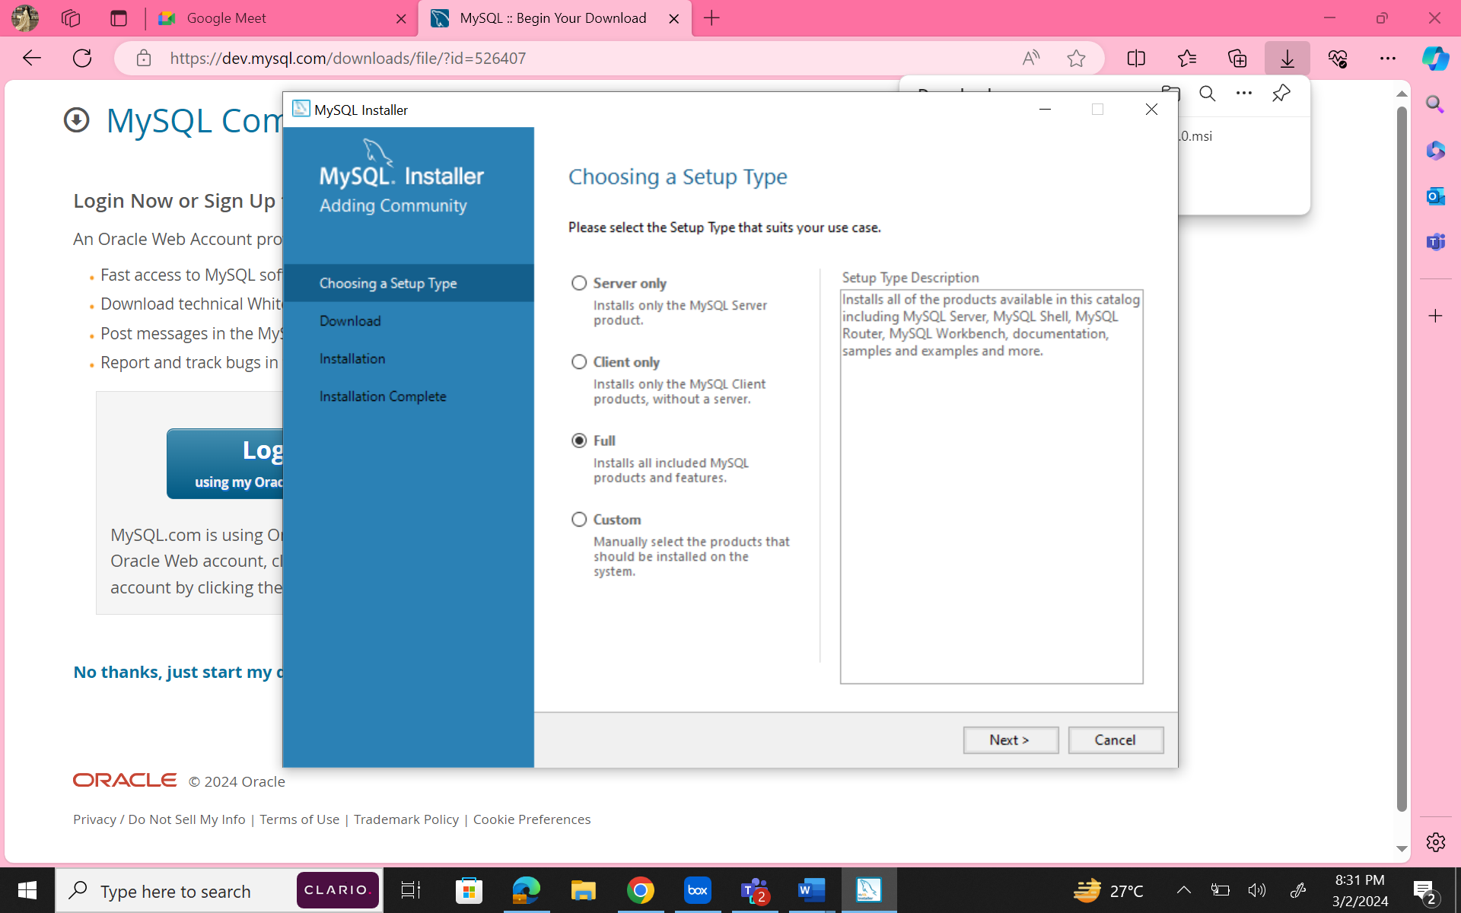

Click on next until following screen

Set a password

example: name@birthdate

Click next until following screen

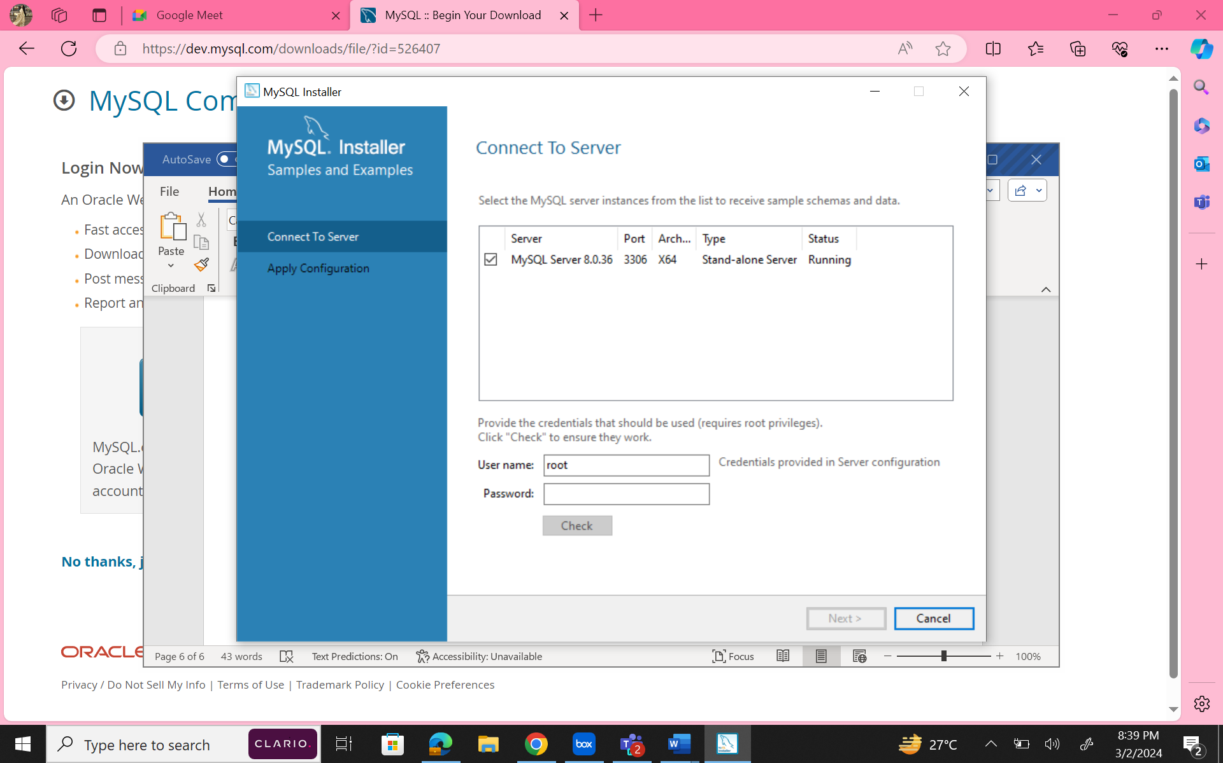

Enter the same password as we set above

Click next until

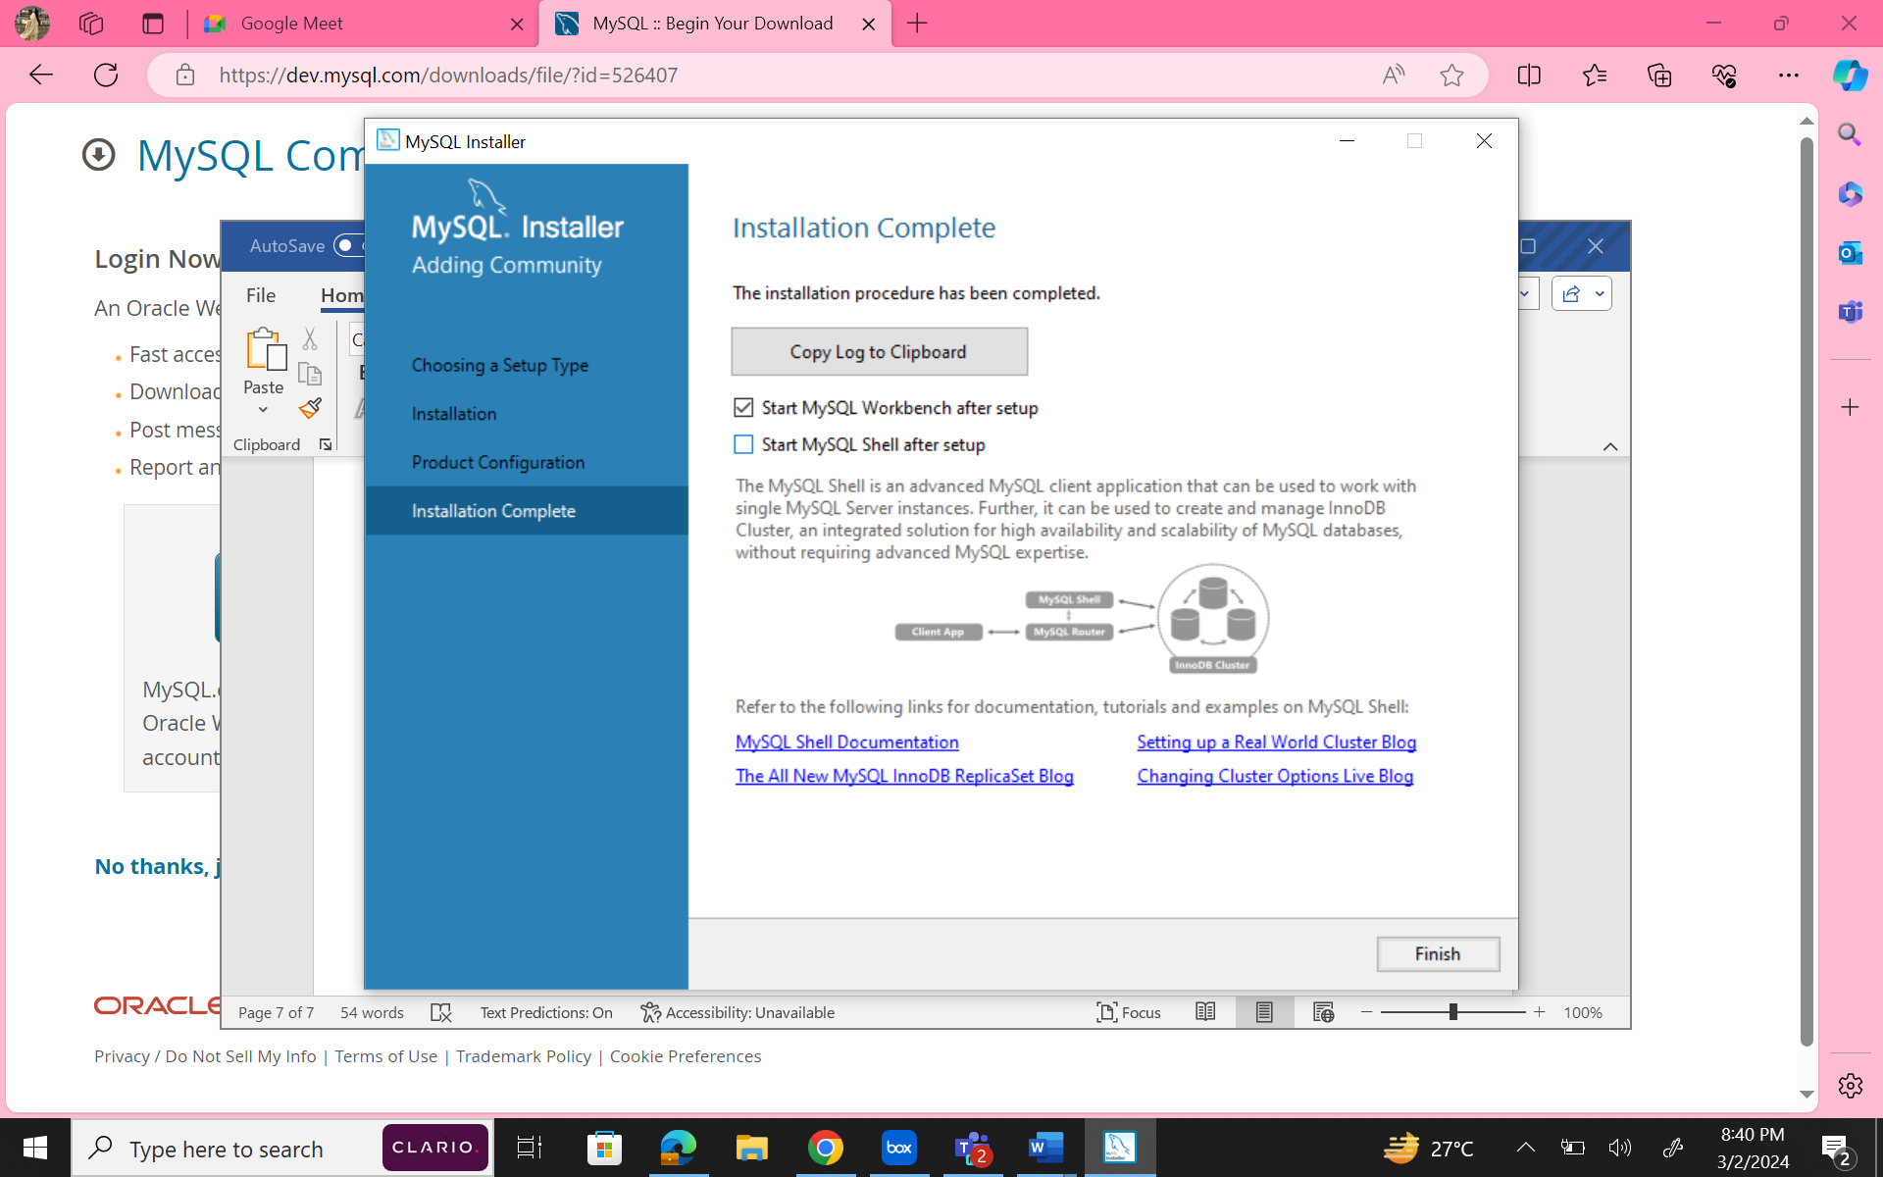

Untick shell after setup as we don’t need it right away. It is okay even if we don’t untick it.

After setup we get:

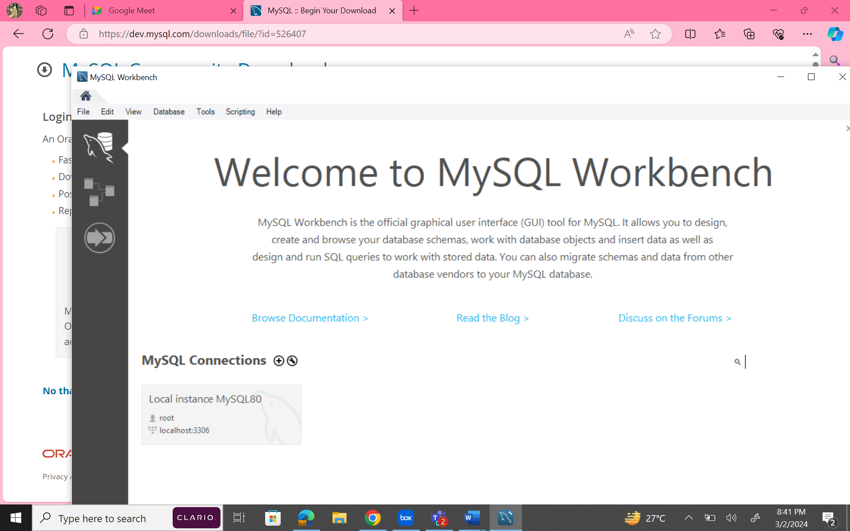

Click on mysql connection. Add password and open

